E-Commerce Database Project Documentation
Shorting & limiting

- SELECT * FROM products ORDER BY price DESC LIMIT 5;

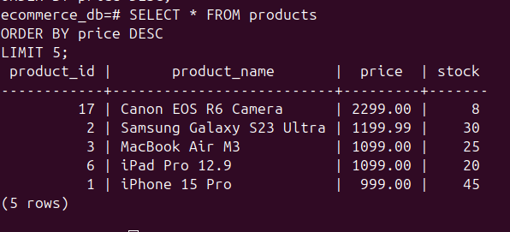
This query is used to retrieve a limited number of records from a table after sorting them based on a specific column.

SELECT order_id, amount FROM payments ORDER BY amount ASC LIMIT 3;

